
I encourage you to respond to these opportunities to partner with UMCOR and our own Dakotas Conference Native American ministries to heal a broken world and transform lives. May we respond willingly and wholeheartedly to the Lord with gratitude, freedom and humbleness born of a giving, God that which has come from God’s hand. Bishop Bruce R. Ough

One-half of the Thanksgiving offering will go to the United Methodist Committee on Relief (UMCOR) hurricane and flood relief efforts.

Hurricane Matthew was a fierce storm that left nearly 1,000 dead in Haiti and at least 38 dead in the United States, with 19 of those in North Carolina.

Six trillion gallons of rainwater fell in just three days, August 12-14, in southern Louisiana. The recovery, though, will take years. Indiana, Iowa, West Virginia are being overwhelmed with the devastation from floodwaters. This level of flooding is unprecedented and has nearly exhausted the resources UMCOR has available for relief and recover efforts.
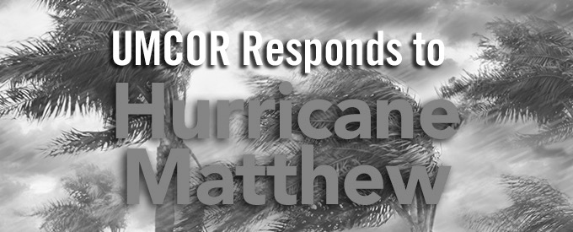
The other half of the Thanksgiving offering will be given to Spirit Lake and Tree of Life Ministries.

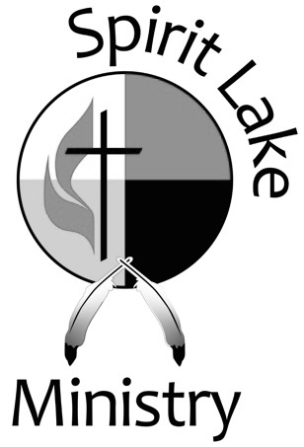
The Spirit Lake Ministry Center is dedicated to supporting the peoples of the Spirit Lake Nation and is an approved United Methodist Volunteer in Mission (VIM) destination. VIM teams perform light construction and maintenance on homes, tribal buildings and grounds on the reservation and to provide team members for children's activities. Spirit Lake Ministry Center also operates a food and clothing pantry, worship and fellowship gatherings.


Tree of Life Ministry was begun in 1985 to establish a Christian presence on the Rosebud Reservation. The ministry has several components including: the Warm Welcome—a daily hot meal and food distribution program, Tree of Life Boutique—a thrift store for clothing and small household items and a construction ministry to repair homes and community buildings.

Every time Char and I are privileged to offer a gift for the expansion of God’s kingdom or the care of God’s children, I am mindful of King David’s prayer: “Who am I, and who are my people, that we should be able to offer so willingly? Since everything comes from you.“
Bishop Ough

