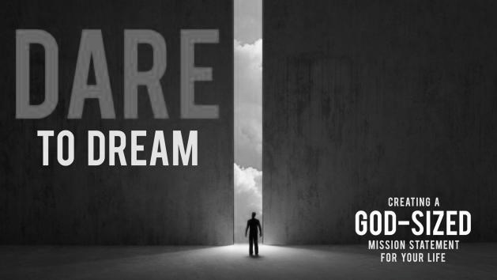
Dreaming the dream – Wake up to God's dream inside you
A message from
Reverend Randy Cross
Eastern Sunrise
District Superintendent

Mike Slaughter asks the question: Am I thinking too small? In his book, Dare to Dream, he wonders if he, we are living on the “just get by plan,” or whether there a greater “God-dream” which if we lived it out, could permeate and inform every move we make?” Those are powerful questions. Let’s explore those questions and others together.

I will live my own life. Each of us does. How long of a life, or the details about where we live, our careers, our relationships, are all different from each other – but for sure, this is my life – these are our unique lives. I’ve always believed that half of my life consists of what happens to me. The other half, however, consists of what I do with what happens to me! What will guide my decisions, become my compass? How great or small, significant or insignificant will my life be judged to be?

Mike quotes scripture to answer part of the question -- Jeremiah 29:11 “God says – I know the plans I have in mind for you.” This indeed may be the life that belongs to me, but it also is the life gifted to me by the God of the universe. God has a purpose for my existence! But how do we discern God’s purpose for us? Even deeper, when I think of the dream I have for my life, how do I make sure it is also truly God’s dream first, and not just something that Randy has conjured up, to fill my own ego?


The first test to make sure that our life’s dream is from God, is to answer whether our hoped-for-outcome appears to only see how “successful” we can become – riches, status, power, and so forth – or whether instead, the dream offers significance to our lives. Do we believe that we are making a difference in God’s kingdom by our work and intentions? Do we believe we sense God’s pleasure in our efforts and actions, and that our world is healthier, holier, because of what we do? I have always believed that Joy comes from living a significant life. Listen to that again: Joy comes from living a significant life. When what we do is aligned, and synched with God’s intentions, then we experience Joy in that significant work and life.

Mike recalls the story of Jacob in the Bible. While traveling in the desert, Jacob stops to rest for the night, and he has a dream. It is a God-sized dream! There is a ladder that connects earth and heaven, and angels are going up and down on it. God appears, and makes three, one-sided promises to Jacob: 1) this land will belong to him and to his descendants; 2) those descendants will be like the dust of the earth, numerous and abundant; and 3) God will not leave Jacob until this is accomplished!

Jacob wakes up, and offers a huge understatement: Wow – God is in this place and I didn’t know it! This is the house of God, and the gate of heaven! What were simply unremarkable things before – just a rock and some sand and such -- now become unbelievably significant, because God has shown up and made it clear to this wanderer that God is in charge.

You see, no longer can the question be, “What do I, Jacob, want to do with my life?” but now it is “What does God want for me as I live before God?” Not “What do I want to be when I grow up?” but “What significant life does God set before me?

Did you know that the verb “to dream” comes from the Old English, meaning “to rejoice” or “to play music?” It appears that our attentiveness to God’s direction in our lives – our God-sized dreams can make us rejoice. They are hopeful, and powerfully life-changing. Mike offers the image of a dream as the narrowest crossing between heaven and earth – a “thin place” where God’s powerful intention and desire for us is spelled out like a clear “Holy whisper” that becomes the guide to our future work and decisions.

In whatever ways you receive your “life-dream” – whether asleep, in daydreams, in study or prayer, recognize that if the dream is significant, then it is God breaking in. Most importantly, however, always remember that when we are willing to accept and live within the God-sized and God-directed dreams, instead of our own ideas and plans, we open ourselves to an incredible journey, of focus, of powerful work, and of significant life, following Christ is all that we do.

God bless you on your Lenten Journey.

“The first test to make sure that our life’s dream is from God, is to answer whether our hoped-for-outcome appears to only see how “successful” we can become – riches, status, power, and so forth – or whether instead, the dream offers significance to our lives.”
Rev. Randy Cross

