Holy Land Pilgrimage with
Bishop Bruce and Char Ough
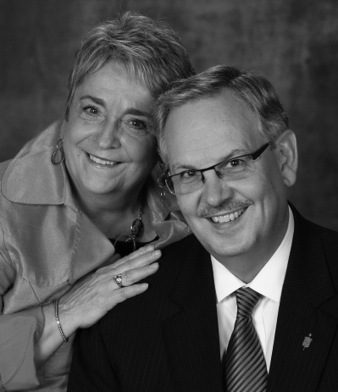
United Methodists across Minnesota and the Dakotas are invited to join Bishop Bruce R. Ough and his wife Char on a pilgrimage to the Holy Land. This unique experience provides an opportunity to grow as a church community and on your own personal faith journey.
The Bible tells us that “when [Jesus] entered Jerusalem, the whole city was in turmoil, asking, ‘Who is this?’” (Matthew 21:10). Travelers on this pilgrimage will explore that question for the ages: “Who is this Jesus?” They will see where Jesus was born, walk where Jesus walked, and stand where Jesus taught and preached. They will pray and worship in the sites made sacred by Jesus.
Invitation From the Bishop
Join me on the shores of the Sea of Galilee, where Jesus fed 5,000 people. Enter the old city of Jerusalem and walk the way of the cross.
I invite pastors, teachers, and church members to join me in this travel-study program that will enrich our understanding of the Christian faith. This journey is one of the best continuing education events I can recommend, and there is no better way I know to have a hands-on experience with the world of the New and Old Testaments. Join with other United Methodists on this important spiritual pilgrimage. Visit the Holy Land.
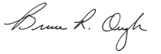
Bishop Bruce R. Ough
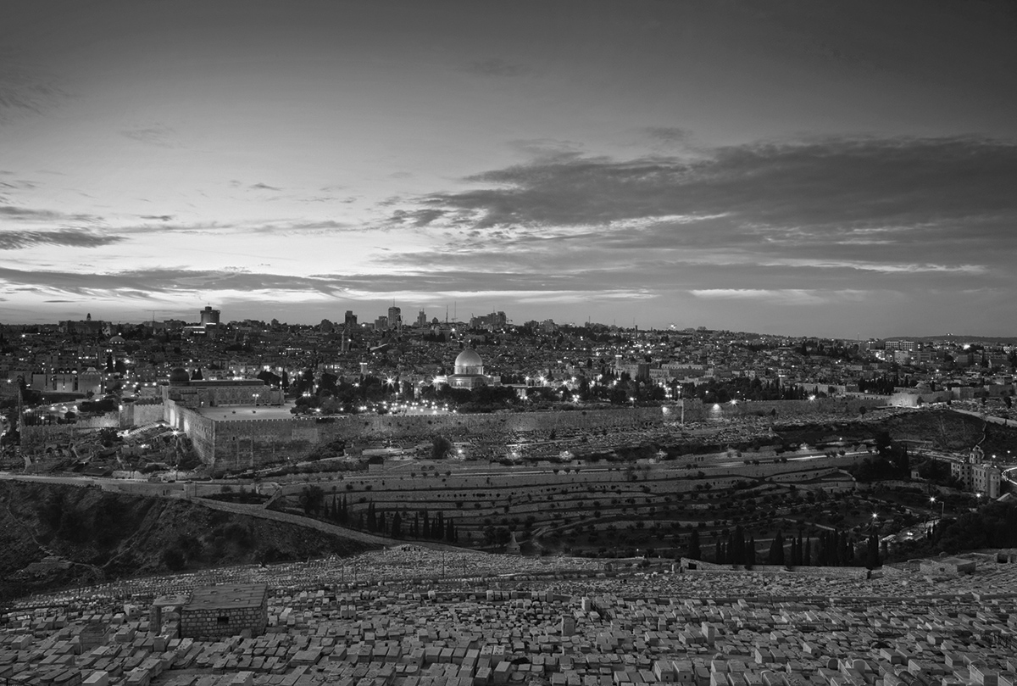
Trip Details
Dates: January 7-16, 2015
Sampling of stops on the journey: Herodion, Jericho, Jordan River Baptismal Site, Ruins of Capernaum, Cana, Nazareth, Mount of Olives, Garden of Gethsemane, Church of All Nations, Mount Zion, Upper Room, Caiaphas’ House, Garden Tomb, Pool of Bethesda
For More Information or to Register:
• Visit www.eo.travelwithus.com
• Click the “Know Your Tour Information?” blue button next to the search bar, and enter the following information:
Tour: HL
Date: 010715
Code: M
Questions? Contact Rev. Mike Miller (952-975-1704 or prairieflowers@q.com)

